Scope, opportunities and challenges for E-Vehicle in India

Institute for Engineering Research and Publication (IFERP) organized a webinar on Scope, opportunities and challenges for E-Vehicle in India, on September 12th, 2020 at 06:30PM (IST) on webinarjam to Know and discuss about the Scopes and Opportunities available for E-Vehicle in India and also about the Challenges usually faced for Development E-Vehicle in India.

SPEAKER

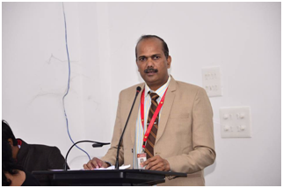

Dr. Anil S. Dube
Professor and Head of Department
Faculty of Mechanical Engineering
Sandip Institute of Engineering and management India

The Keynote Speaker broadly discussed on the following topics,

- Need Of E Vehicle
- Government Initiative For E Vehicle
- Current Status Of E Vehicle In India
- Business Opportunity In E Vehicle
- Challenges For E Vehicle.

Highlights of the Webinar:
- E-certificate was provided to all attendees.
- Free IFERP membership was provided to all attendees with membership certificate.
- Telecasted Live on YouTube.

YouTube Channel Link: https://www.youtube.com/watch?v=olOsdcqq0Zw

The webinar was attended by more than 100 attendees and viewed live by more than 187 subscribers on YouTube.

